W-12
YEAR 10 SCIENCE
BIOLOGICAL SCIENCE
TEST 1 - CELLS

NAME: MARK: 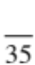

Mark | ND | NW | C | O
Mark Range | <10 | 10-15 | 16 - 24 | 25 - 35

1. Label the parts of the cell as shown in the diagram below.

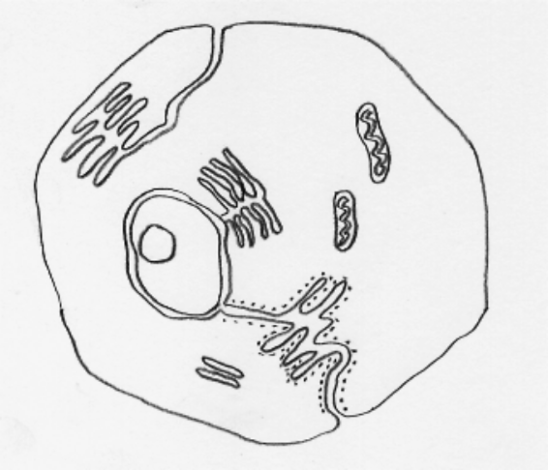
(small dot)
(6)

2. Complete the following table, giving the name of the part of the cell (animal or plant) responsible for
the process.

Role Or Function In The Cell | Name of Part
Protects the cell and lets substances in and out.
Produce spindles for chromosome separation in cell division.
Produces energy for the cell.
Controls the functions within the cell.
Produces proteins for the cell.
(5)

3. (a) Name the four bases in a DNA strand.

(4)

(b) Match the 4 bases into 2 pairs of bases that go together.

(2)

(c) Draw a simple diagram to show how a short section of a chromosome would look.
(Draw only 5 pairs of bases. Choose any combination you like.)

(2)

4. Mitosis occurs in normal body cells. Answer the following questions about this process.

(a) How many chromosomes are in a normal human cell?

(b) At the end of mitosis, how many daughter cells are produced from one parent cell?

(c) How many chromosomes are found in each daughter cell?

(d) Is the answer to part (c) the haploid or diploid number?

(4)

5. In the space below, draw the various stages in mitosis. Next to each drawing, give the name of the
stage and what is happening in the cell.

Stage Name | Drawing | Description
(5)
6. OPTIONAL

Meiosis is an important process in the human body. It occurs in two parts.

(a) In which cells of the body does it occur? (1)

(b) How many daughter cells does the process produce? (1)

(c) Draw a series of simple diagrams to SHOW THE FIRST PART OF MEIOSIS. Name each
stage and state what is happening in the cell at each stage.

Stage Name | Drawing | Description

(5)

